

TASK #4
REPORT #4
1. Problem Statement and Objective
A campus navigation system knows the travel cost that has already been spent g(n) and also has an estimate of the remaining cost, h(n). It needs to reach a destination while exploring few irrelevant states as possible compared to an uninformed search. This lab uses the A* search algorithm, which orders the frontier based on the evaluation function f(n) = g(n). H(n) on a weighted campus graph. The goal is to check whether the result from A* is both optimal and efficient when compared to Uniform-Cost Search (UCS).
The objectives of this lab are to:
- Compute. Interpret g(n) h(n) and f(n) both by hand and through code.
- Implement A* using a priority queue, including handling best-cost tables, stale entries and path reconstruction.
- Check the supplied heuristic for admissibility and consistency by verification not by assumption.
- Compare A* with a version of UCS that uses a zero heuristic using the number of expanded states as a measure of efficiency on the same problem.
- Intentionally overestimate one heuristic value and show how this can lead to loss of optimality.
1 .Assumptions
Buildings are represented as nodes in the graph, where S's the starting building and G is the destination. The edges between buildings are. Their weights represent travel time in time units. The heuristic values are estimates of time in the same units as the edge costs. These are not distances measured in meters and straight-line distances, in meters are never added directly to travel time.

All edge weights are positive. This means UCS and A* are well defined. No negative-cost cycles exist.
Tie-breaking is deterministic. The queue is sorted as tuples (f g node path). This makes ties broken first by f then by smaller g then by alphabetical node name. Successors are created in the order they appear in the adjacency list.
Counting convention is used the same in every run. A node counts as expanded when its successors are examined. Goal processing is logged as "G(goal)". Is not counted. Stale queue entries are logged as "(stale)". Are not counted.
2.Graph and Heuristic Used
The graph and heuristic are exactly those supplied in the lab manual (Sections 4.2 and 4.4).
Edge (u → v) | Travel cost w
S → A | 1
S → B | 4
A → C | 2
B → G | 5
C → G | 3
There are exactly two complete routes from S to G:
- S → A → C → G with cost 1 + 2 + 3 = 6 (optimal);
- S → B → G with cost 4 + 5 = 9.
The supplied heuristic is h(S)=5, h(A)=4, h(B)=4, h(C)=2, h(G)=0.
3 .Implementation Choices
The implementation is in lab4_astar_audit.py (the same logic is in the notebook lab4_astar_audit.ipynb). The main design choices are:
Frontier is represented as (f g node path) tuples. The queue is a Python list that is sorted before each pop. This gives tie-breaking (f then g then node name) and is easy to print for the manual trace. For graphs heapq would be faster; but for this 5-node graph the behavior is identical to the heapq version in the manual.
Best dictionary. Best[node] stores the lowest g found far. A successor is pushed only if ng < best[nxt] so a better path to a node replaces the one.
Stale-entry check. When a popped entry has g != best[node] it is a duplicate. It is logged as "(stale)". Skipped, not expanded.
Goal test on pop not on push. The goal is tested when it is removed from the queue. This guarantees optimality (with a heuristic) because a cheaper path to G could still be waiting in the frontier when a node is pushed.
Rich return value. A_star returns (cost, path, expanded list, processed list) so the same function supports the trace, for UCS control and the expansion counts. If the queue empties it returns (none, None expanded, processed).
UCS control. UCS is obtained by passing a zero heuristic (h(n)=0 for all n) to the function so graph start goal tie-breaking and counting rules are identical; only h changes.
Independent verification. Path_cost() re-sums the edge weights along the path so the returned cost is checked independently. True_cost() computes the remaining cost for the admissibility audit and a loop checks h(u) ≤ w + h(v) on every edge for consistency.
The complete source code is given in appendix A and the captured output in Appendix B.
5. Task 1. Manual g, h f Calculation (First Three Expansions)
Prediction before running (Heuristic Audit activity). Initially f(S) = 0. 5 = 5 So S is the candidate. After S the successors are A. B. I predicted A would be next because it has the smaller f and the code output confirmed this.
Expansion 1. Select S
selected: S, g = 0 h = 5, f = 0. 5 = 5.
Successor A: g = 0 + 1 = 1 h = 4, f = 1 + 4 = 5.
Successor B: g = 0. 4 = 4 H = 4, f = 4 + 4 = 8.
Remaining frontier: A (g=1, h=4, f=5) B (g=4, h=4, f=8).
Why A is next: f(A) = 5 is smaller than f(B) = 8.
Expansion 2. Select A
Selected: A, g = 1 h = 4 f = 1 + 4 = 5.
Successor C: g = 1 + 2 = 3 h = 2 f = 3 + 2 = 5.
Remaining frontier: C (g=3, h=2 f=5) B (g=4, h=4, f=8).
Why C is next: f(C) = 5 is smaller than f(B) = 8.
Expansion 3. C
Selected: C, g = 3 h = 2 f = 3 + 2 = 5.
Successor G: g = 3 + 3 = 6 h = 0 f = 6 + 0 = 6.
Remaining frontier: G (g=6, h=0 f=6) B (g=4, h=4, f=8).
Why G is next: f(G) = 6 is smaller, than f(B) = 8 so G is selected next recognised as the goal and the search stops with cost 6. B is never expanded.
# | Selected | g | h | f = g + h | Frontier after expansion (node: g, h, f) | Next
1 | S | 0 | 5 | 0 + 5 = 5 | A: 1, 4, 5 | B: 4, 4, 8 | A
2 | A | 1 | 4 | 1 + 4 = 5 | C: 3, 2, 5 | B: 4, 4, 8 | C
3 | C | 3 | 2 | 3 + 2 = 5 | G: 6, 0, 6 | B: 4, 4, 8 | G
The manual calculation matches the program output so the trace is confirmed by the code. Notice that f stays at 5 along the path S A C and only goes up to 6 at G. The f-values along a path never go down and none go beyond the optimal cost of 6.
4. Heuristic Audit
4.1 Admissibility (h(n) ≤ remaining cost)
The true remaining cost of a node is the cheapest path cost from that node, to G. Looking at the graph: S = min(1+2+3 4+5) = 6; A = 2+3 = 5; B = 5; C = 3; G = 0.
Node | h(n) | True remaining cost | h ≤ true?
S | 5 | 6 | True
A | 4 | 5 | True
B | 4 | 5 | True
C | 2 | 3 | True
G | 0 | 0 | True
Table 3: Admissibility check of the supplied heuristic (code output "admissibility check (h)").
Every node satisfies h(n) ≤ true cost, so the supplied heuristic is admissible on this instance. This was established by explicit verification on this small graph, not assumed.

4.2 Consistency (h(u) ≤ cost(u,v) + h(v) on every edge)
Edge u → v | h(u) | cost(u,v) + h(v) | h(u) ≤ cost + h(v)?
S → A | 5 | 1 + 4 = 5 | True
S → B | 5 | 4 + 4 = 8 | True
A → C | 4 | 2 + 2 = 4 | True
B → G | 4 | 5 + 0 = 5 | True
C → G | 2 | 3 + 0 = 3 | True
Table 4: Consistency audit of the supplied heuristic (code output "consistency audit (h)").
All five edges pass, so the heuristic is consistent. Consistency means f(n) never decreases along a path, which is exactly what Table 2 shows (5, 5, 5, 6). Consistency also guarantees that once a node is expanded its g-value is optimal, so no stale re-expansions are needed.

5. Task 2 — A* versus UCS
A* (supplied heuristic) and a UCS control (all h = 0) were run on the same graph, same start S, same goal G, same tie-breaking and same counting convention.
Measure | A* (supplied h) | UCS (h = 0)
Returned path | S → A → C → G | S → A → C → G
Returned cost g | 6 | 6
Independently summed cost | 6 | 6
Processed-node trace | S, A, C, G(goal) | S, A, C, B, G(goal)
Expanded nodes | S, A, C | S, A, C, B
Expansion count | 3 | 4
Stale entries | 0 | 0
Interpretation
Same answer with work. Both find the path with a cost of 6 and the total cost matches the sum of individual costs. A* looked at 3 nodes while UCS looked at 4. That is a saving of one node (25%). The efficiency claim is based on the steps taken not on how long the path is.
Why does UCS expand B. UCS only looks at the cost far. After C is checked the list has B with a cost of 4 and G with a cost of 6. Since 4 is than 6 UCS checks B first even though B leads to a more expensive route. A* gives B a value of 4 plus 4 equals 8. That is than 6 for G so B is not checked.
Goal counting. G shows up in the results of both runs as "G(goal)". Is not counted as a check. So the counts are 3 and 4 not 4 and 5. The same rule is used in both runs so the comparison is fair.
Stale entries. No stale entries happened in either run. In UCS B is. Offers G with a cost of 4 plus 5 equals 9.. 9 Is not better than the best G cost of 6. So no new G entry is added. In A* B is never checked so it never offers a way to G. Stale entries only happen when a node is added first with a worse cost and later improved. The graph never causes this.
Limit of the evidence. The difference is one node in a five-node graph. It shows how it works but is not a measure of speed.
6. Task 3. Single-Value Overestimate Experiment
one heuristic value was changed. H(C) went from 2 to 10. H(G) is 0. Everything else in the graph the start the goal and the tie-breaking were not changed. The real cost from C is 3 so h(C) = 10 is higher, than 3. That means the heuristic overestimates by 7 (10 > 3). The admissibility check says false for C.
Measure | Original h(C) = 2 | Modified h(C) = 10
h(C) vs true remaining cost 3 | 2 ≤ 3 (admissible) | 10 > 3 (overestimate)
Returned path | S → A → C → G | S → B → G
Returned cost g | 6 | 9
Independently summed cost | 6 | 9
Processed-node trace | S, A, C, G(goal) | S, A, B, G(goal)
Expanded nodes | S, A, C | S, A, B
Expansion count | 3 | 3
Optimal? | Yes | No (9 > 6)
Table 6: Effect of overestimating h(C) (code output "task 3").

What changed and why
- S is expanded: A gets f = 1 + 4 = 5 and B gets f = 4 + 4 = 8.
- A is expanded: C gets g = 1 + 2 = 3, and with the inflated heuristic f(C) = 3 + 10 = 13. The frontier is B (f=8), C (f=13).
- B has the smaller f (8 < 13), so B is expanded: G gets g = 4 + 5 = 9, f = 9 + 0 = 9. The frontier is G (f=9), C (f=13).
- G (f=9) is now smaller than C (f=13), so G is popped and recognised as the goal. The search returns the cost-9 route S → B → G and never examines C, whose continuation C → G would have given the cost-6 route.
The path changed from cost 6 to cost 9, so the answer changed. The expansion count stayed at 3, which shows that the count alone cannot reveal the loss of optimality; the independent cost check does.

Why an overestimate removes the optimality guarantee
With an admissible heuristic, every node n on an optimal path has f(n) = g(n) + h(n) ≤ the optimal cost C*. Such a node therefore cannot be stuck behind a goal entry whose f equals a worse cost, so it is expanded before any suboptimal goal is popped. An overestimate breaks exactly that inequality: f(C) = 13 exceeds even the suboptimal solution cost 9, so the cheaper route is pushed behind the worse goal and is lost. A* trusts f as a lower bound, and an overestimate makes that lower bound false.

Why an overestimate may still look "unchanged" (extra sensitivity test)
To show that one unchanged run proves nothing, I re-ran the same program with different values of h(C) (only h(C) changed each time). The true remaining cost of C is 3.
h(C) | Admissible? | Returned path | Cost | Expanded | Count
2 (original) | Yes | S-A-C-G | 6 | S, A, C | 3
3 | Yes (exact) | S-A-C-G | 6 | S, A, C | 3
4 | No | S-A-C-G | 6 | S, A, C | 3
5 | No | S-A-C-G | 6 | S, A, C | 3
6 | No | S-A-C-G | 6 | S, A, B, C | 4
7 | No | S-B-G | 9 | S, A, B | 3
10 (task value) | No | S-B-G | 9 | S, A, B | 3

h(C) = 4, 5 and 6 are all overestimates (4, 5, 6 > 3), yet A* still returns the optimal cost 6; with h(C) = 6 the cost is even unchanged but the expansion count rises to 4 because the tie f = 9 is resolved by the (f, g) ordering. Only from h(C) = 7 upward does f(C) = 3 + h(C) exceed 9 and the optimal route is lost. Therefore, a run that happens to be unchanged does not prove an inadmissible heuristic is safe: the guarantee is lost, even if a particular input does not expose it. (These extra rows were produced by re-running the same A_star function with only h(C) altered.)

7. Edge Case and Failure Analysis

7.1 Edge case: goal unreachable
Aspect | Description
Input | graph_nogoal = {"S": [("A", 1)], "A": [], "G": []}; h_nogoal = {"S": 1, "A": 1, "G": 0}; start S, goal G. G exists as a node but has no incoming edge.
Observed behaviour | The program printed "No path found ['S', 'A']". A_star returned (None, None, ['S', 'A'], ...) after exhausting the queue; no exception was raised and no wrong path was returned.
Likely cause | The search expanded every reachable node (S, A), the frontier became empty, and the while-loop ended without the goal ever being popped. The final return statement handles this case explicitly.
Proposed improvement | Return a clearly named result (for example a small dataclass with found=False), and optionally run a quick reachability check (BFS) before searching. Also validate that every node has an h entry and that all edge weights are positive, because a missing h entry would cause a KeyError.

8. Limitations
Tiny instance. The graph contains five nodes and two routes. Because of this the gain in efficiency—three expansions of four—only shows how the method works. It does not serve as a benchmark. No claim is made about graphs.
Abstract heuristic. The h values are given as abstract time estimates not from measured campus data. Therefore the results reveal nothing about campus travel times.
Admissibility proved by enumeration. The function true_cost() uses recursion and the min() function. It works because the graph is small and acyclic and every non-goal node has successors. It would fail on cycles or on dead-end nodes, where min() would be called on a list.
Sorted list of heap. The code calls q.sort() on every iteration, which costs O(n log n) for each step. Using heapq would be more efficient for large graphs.
Tie-breaking dependence. The expansion count for h(C) = 6 depends on the tie-breaking rule, such, as (f g, node). A different rule could change the count though it would not change the cost.
Single run, no timing. Only the number of expansions was measured. Runtime and memory usage were not recorded.

9. Reflection
What did I learn today? I learned that A* is UCS plus a heuristic and that A* guarantee depends on the being admissible. I also learned to test quality with explicit tables rather than assume it.
How will I apply this in an AI system? In a navigation or game-pathfinding system I would build the heuristic from a lower bound for example travel time computed from the maximum possible speed and run an audit script before deployment so that an overestimate cannot silently return a longer route.
What. Surprised me? I was surprised that with h(C) = 10 the expansion count stayed at 3 while the cost jumped from 6 to 9; expansion count alone hid the failure. I was also surprised that h(C) = 4, 5 and 6 are overestimates. Still returned the optimal path, which shows that a single passing test is not proof.
What would I do differently time? I would use heapq for the frontier add input validation for missing h entries and non-positive weights, test on a larger graph with several routes and add runtime measurements, alongside expansion count.

10. SOUCE CODE

TASK 1

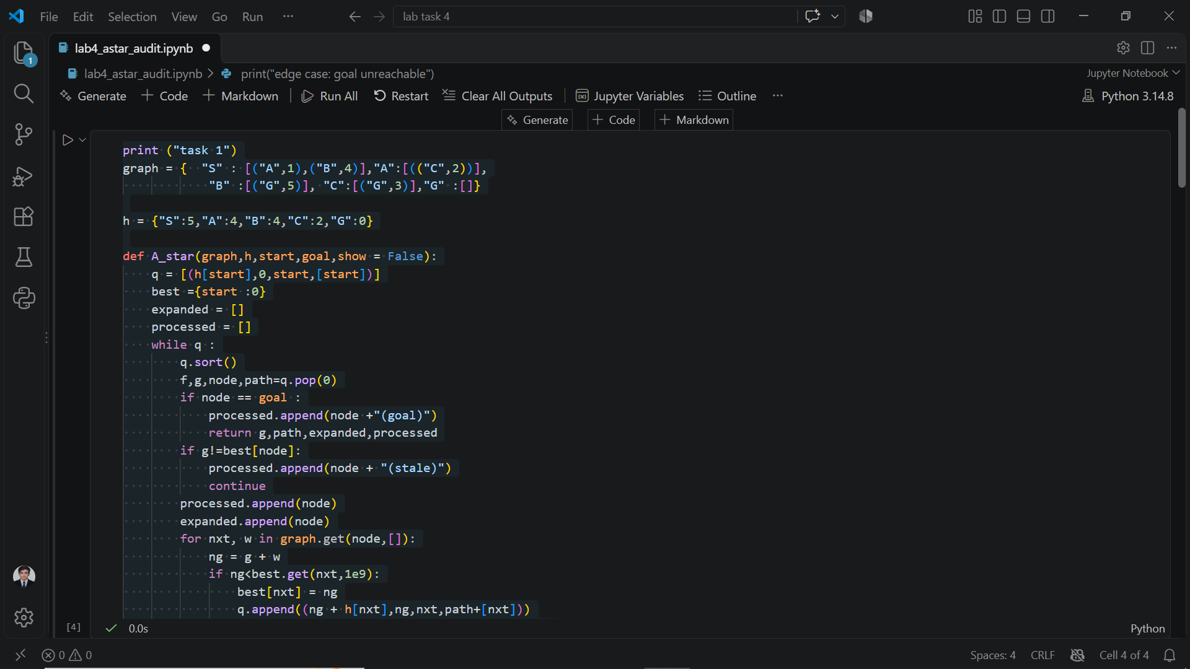
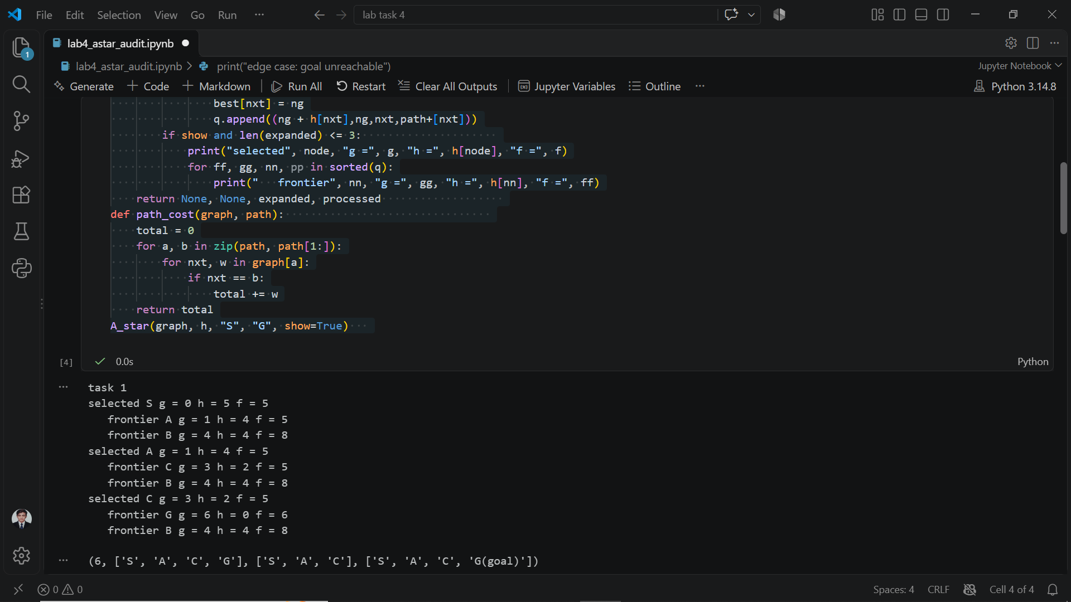

TASK 2 :
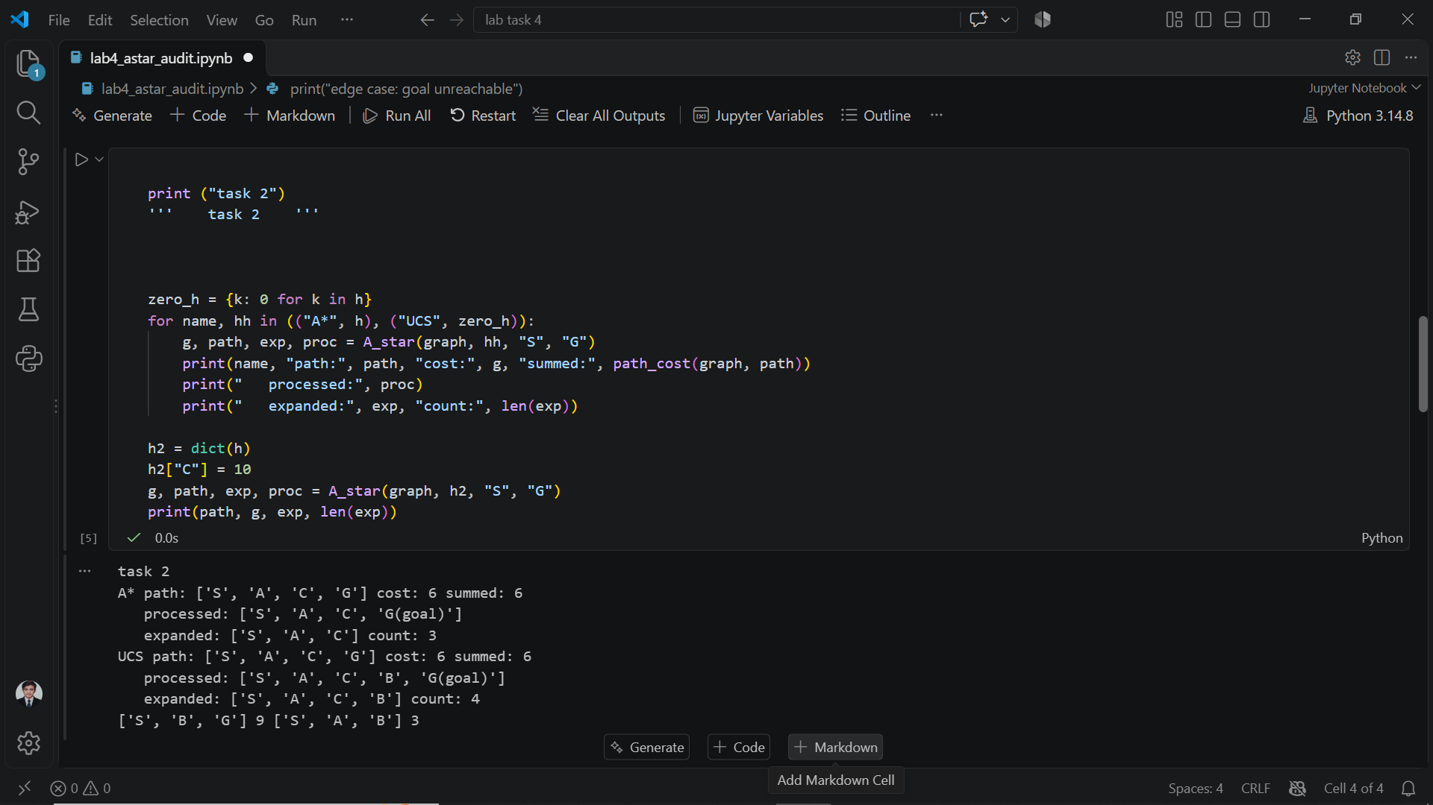

TASK # 3
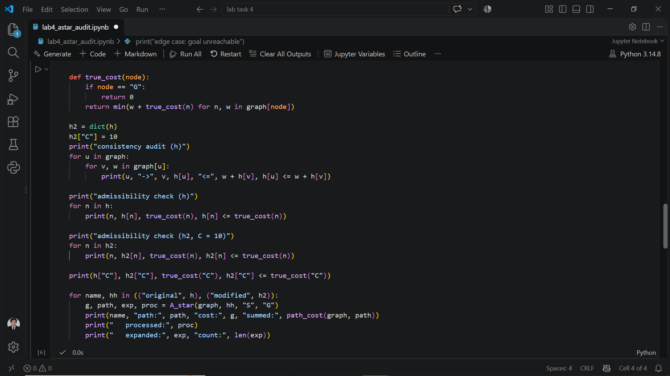
11.OUTPUT
